# Requirements Document

**Date:** December 2, 2018

**Date Submitted:** December 5, 2018

**Application Title:** Steve’s Pizza Factory

**Purpose:** This object-oriented application will allow the user to create a pizza order. The user can choose carry-out or delivery types. The user can choose a Specialty pizza or create a pizza to add to their order.

**Procedures:** If the user picks a specialty pizza, they are taken to a screen that allows them to modify the pizza before adding to order. If the user picks to create a pizza, they are taken to a screen that allows them to choose the size and the crust type. The next screen the user can choose the sauce type, cheese type, and bake type. The next screen allows the user to pick toppings. The next screen allows the user to modify the pizza before adding to the order.

When the user is done modifying either their specialty or custom pizza, the next screen allows the user to edit the current order, add another pizza, or checkout. If the user picks to edit current order, they can delete a pizza from the order. If they choose to add another pizza, the go through the steps to add a pizza.

If they choose to checkout when the order type is carry-out, then the user must add carry-out information. If the order type is delivery, then the user must enter their address information.

When the user clicks next they are taken to a screen which displays the details of the order. This screen will show Subtotal, Tax rate, actual tax, and Total. The user must click submit order to complete the order.

When the user clicks to submit the order, they are taken to a screen that details the order including the time it will be ready, order number, and bill details. Then the user can click ok and make another order if desired.

**Conditions:** 1. The user must be able to add multiple pizzas to an order.

2. The user must be able to modify pizzas in an order.

3. The user must be able to modify an order.

4. The user must be able to modify order type (carry-out or delivery).

5. The user must see receipt information like order tax, subtotal, totals, delivery charge.

**Restrictions:** The user should not be able to press next until they have chosen a size, crust type, sauce type, cheese type, bake type.

The user must enter valid address information if order type is Delivery.

The user can only add maximum 10 toppings to a pizza.

**Comments:** All forms should populate pizza current options when loaded.

# Use Case Definition Document

1. Window displays a carry-out button and a delivery button.
2. User clicks either carry-out button or delivery button.
3. Next window displays 5 specialty pizza buttons and one custom pizza button.
4. If user clicks a specialty pizza, the next screen shows them the pizza details and allows the user to make changes and click add pizza.
5. If the user clicks custom pizza, the next screen allows them to choose the size and the crust type and clicks next
6. The next screen allows the user to choose sauce type, cheese type, bake type and clicks next.
7. The next screen shows all the pizza toppings the user can choose and clicks next.
8. The next screen shows the pizza details the same as step 4 and allows the user to make changes and click add pizza.
9. The next screen shows the current order and allows the user to delete a pizza, edit a pizza, add another pizza, checkout, and see bill details.
10. If the user clicks checkout and the order type is carry-out the user is taken to a carry-out information screen.
11. If the user clicks checkout and the order type is delivery, then the user is taken to a delivery information screen and user clicks next.
12. The user is taken to an order summary screen with order details, and the customer information.
13. If the user clicks submit order, then the user see the receipt.

# Mockups

1.

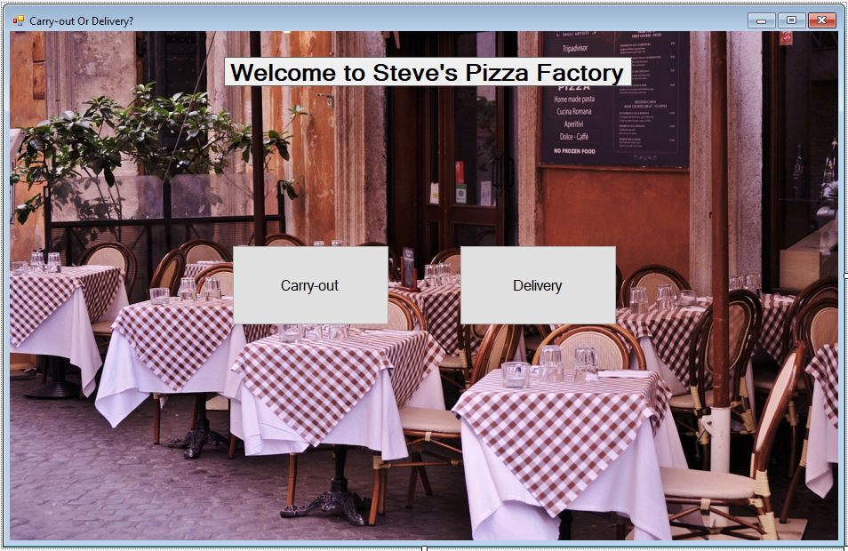

3.

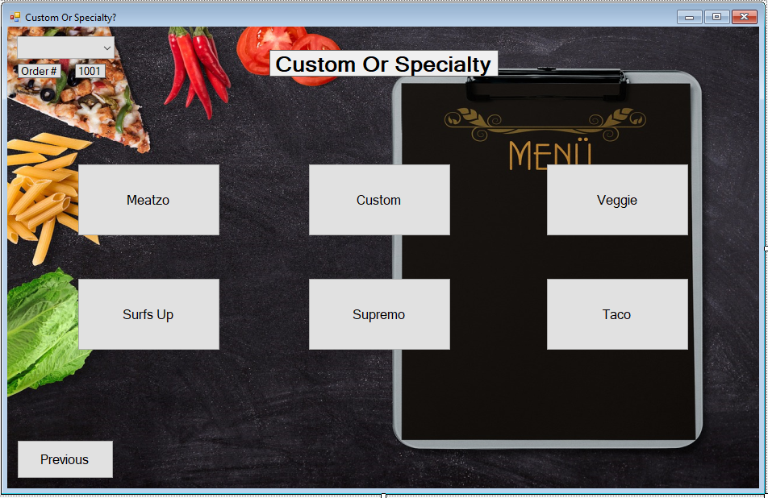

4.

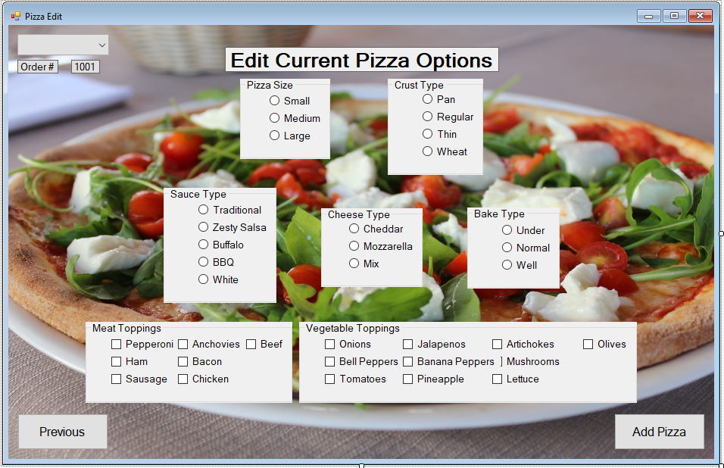

5.

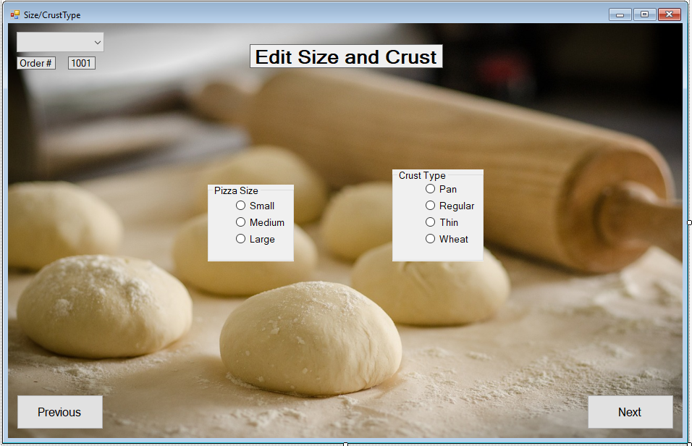

6.

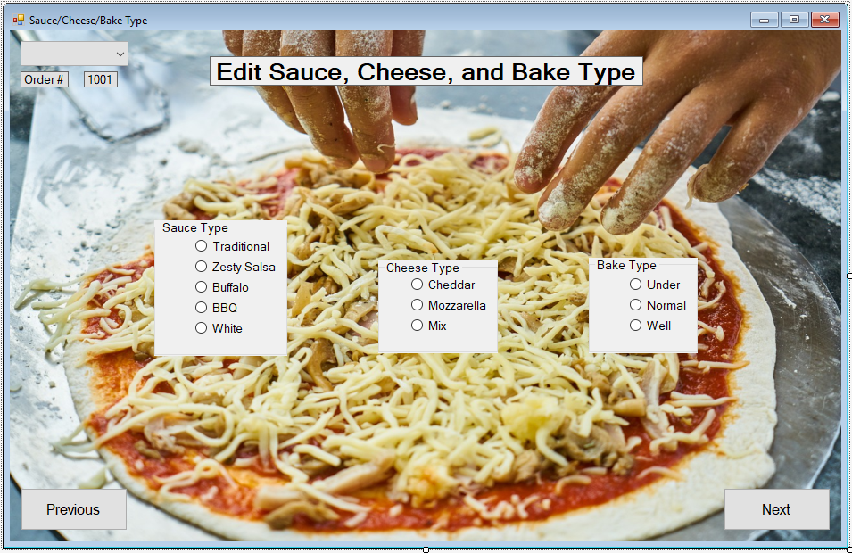

7.

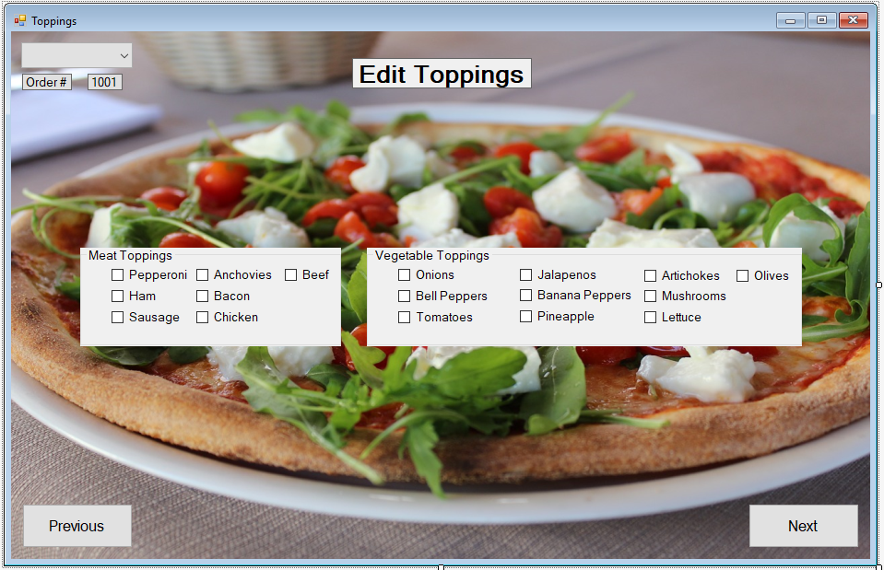

9.

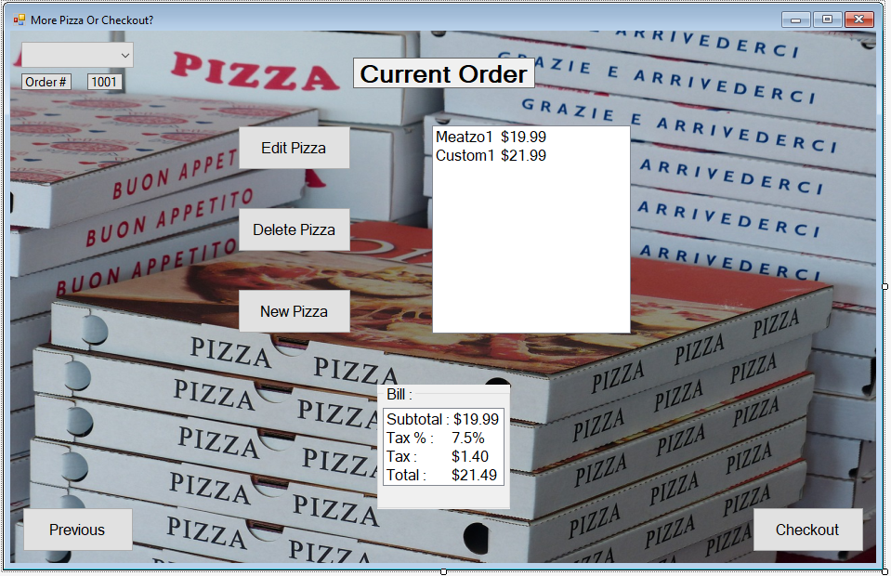

10.

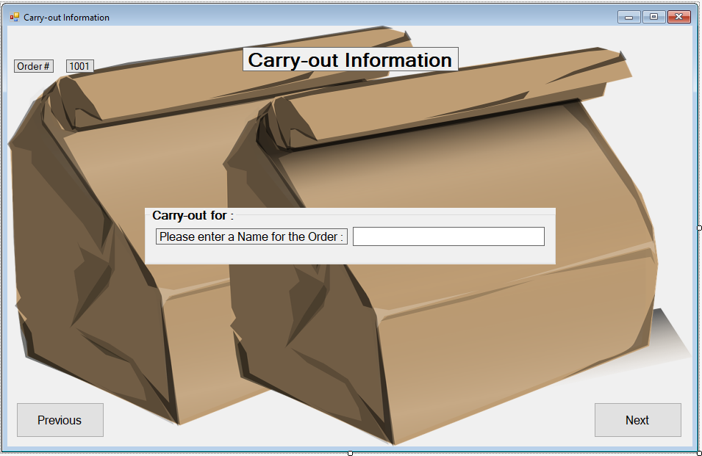

11.

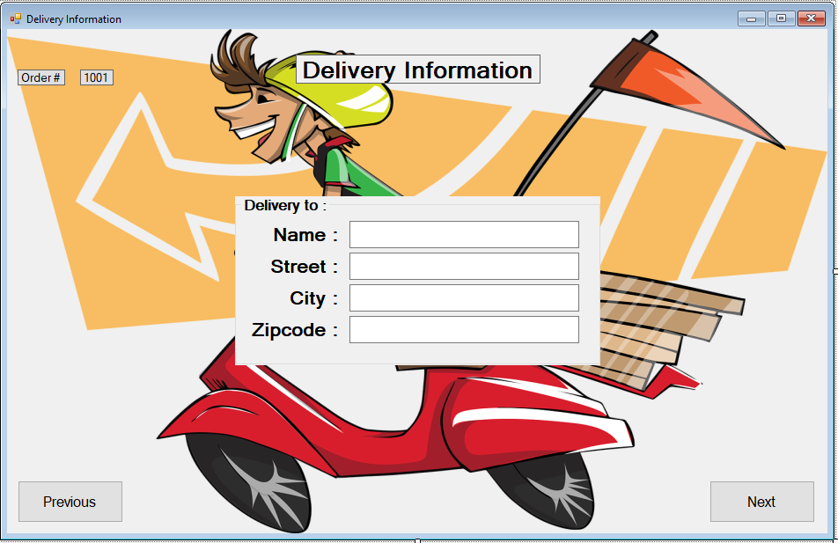

12.a Carry-out

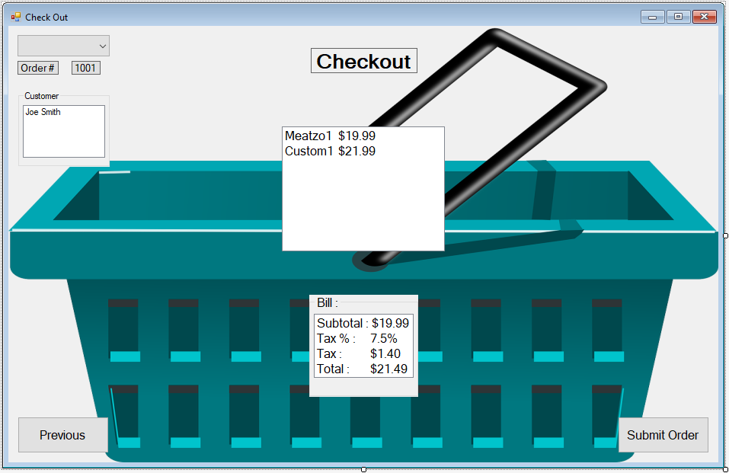

12.b Delivery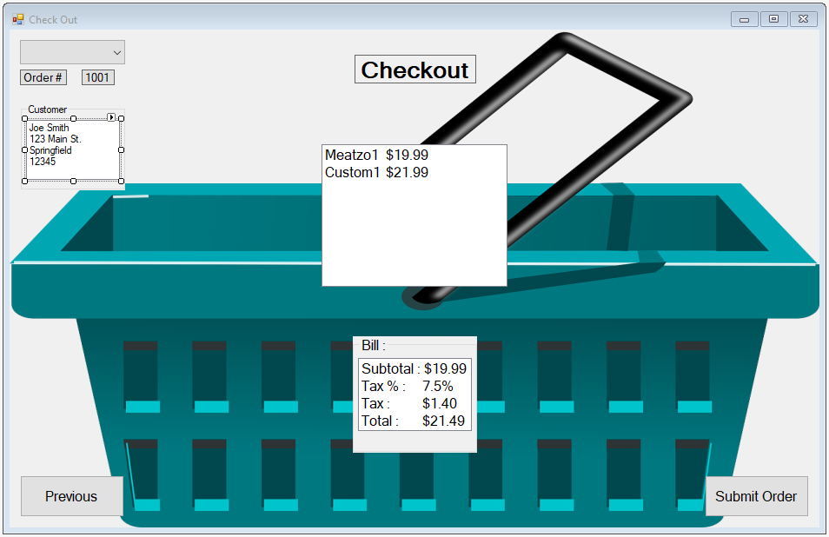

13.

